APQB 6.5 Exchange Rates and Exports/Imports
- If a nation’s currency appreciates relative to that of its trading partners, what will happen to the nation’s exports, imports and aggregate demand?
 | Exports | Imports | Aggregate Demand
A | Increase | Decrease | Increase
B | Increase | Increase | Increase
C | Decrease | Increase | Increase
D | Decrease | Increase | Decrease
E | Decrease | Decrease | Decrease

- England and France are trading partners. If England’s currency, the pound sterling, depreciates relative to France’s currency, the euro, which of the following will happen?
- French exports to England will increase.
- French imports from England will decrease.
- Aggregate demand will increase in France.
- Aggregate demand will increase in England.
- Aggregate demand will decrease in England.
- A depreciation of the United States dollar in foreign exchange markets will result in which of the following?
- A decrease in aggregate demand because net exports will increase.
- A decrease in aggregate demand because imports will decrease.
- A decrease in aggregate demand because exports will increase.
- An increase in aggregate demand because imports will decrease.
- An increase in aggregate demand because exports will decrease.
- Assume that the United States central bank sells government bonds on the open market. How will the sale affect the value of the United States dollar on the foreign exchange market and United States exports?
 | Value of Dollar | Exports
A | Increase | Decrease
B | No Change | Decrease
C | Decrease | Decrease
D | Decrease | Increase
E | Increase | Increase
- Assume that the Federal Reserve pursues a contractionary monetary policy. Based on the resulting change in the interest rate, what will happen to the international value of the dollar, United States imports, and United States exports?
 | International Value of Dollar | United States Imports | United States Exports
A | Increase | Increase | Increase
B | Increase | Increase | Decrease
C | Increase | Decrease | Increase
D | Decrease | Increase | Decrease
E | Decrease | Decrease | Increase
- Assume a flexible exchange rate system. When a country’s currency depreciates on the foreign exchange market, which of the following will most likely happen in the country in the short run?
- An increase in aggregate demand
- A decrease in aggregate demand
- A decrease in the price level
- An increase in the money supply
- A decrease in the money supply
- If the value of the United States dollar increases on the foreign exchange market, which of the following is most likely to occur in the short run?
- Aggregate demand will decrease.
- Aggregate demand will increase.
- Aggregate supply will decrease.
- Both aggregate demand and aggregate supply will decrease.
- Both aggregate demand and aggregate supply will increase.
- If the exchange rate between the United States dollar ($) and the British pound (£) changed from $2 per £1 to $3 per £1, and domestic prices in both countries stayed the same, then the United States dollar would
- depreciate, making United States imports from Britain more expensive
- depreciate, making United States imports from Britain cheaper
- appreciate, making United States imports from Britain more expensive
- appreciate, making United States imports from Britain cheaper
- purchase 3 times more British goods than before the change occurred
- Assume that Canadian consumers increase their demand for Mexican financial assets How would the international supply of Canadian dollars, the value of the Mexican peso relative to the Canadian dollar, and Canadian net exports to Mexico change?
 | Supply of Canadian Dollars | Value of the Peso | Canadian Net Exports
A | Increase | Increase | Increase
B | Increase | Increase | Decrease
C | Decrease | Increase | Decrease
D | Decrease | Decrease | Increase
E | No Change | Increase | Decrease

- An increase in the international value of the United States dollar will tend to cause
- United States exports to fall
- the national income of the United States to increase
- employment in the manufacturing sector of the United States to increase
- the inflation rate in the United States to increase
- the growth rate of the United States economy to increase

Free Response
- Directions: You are advised to spend the first 10 minutes reading all of the questions and planning your answers. You will then have 50 minutes to answer all three of the following questions. You may begin writing your responses before the reading period is over. It is suggested that you spend approximately half your time on the first question and divide the remaining time equally between the next two questions.
Include correctly labeled diagrams, if useful or required, in explaining your answers. A correctly labeled diagram must have all axes and curves clearly labeled and must show directional changes.
The exchange rate between the Australian dollar and the Indian rupee is determined in a flexible foreign exchange market.
a. Assume India is currently in recession. What fiscal policy action could the Indian government take to eliminate the recession?
b. What would be the effect of the fiscal policy action identified in part (a) on interest rates in India?
c. Draw a correctly labeled graph of the foreign exchange market for the Australian dollar. Show on your graph the impact of the change in interest rates identified in part (b) on each of the following.
i. The supply of Australian dollars
ii. The equilibrium exchange rate of the Australian dollar
d. What would be the effect of the change in the exchange rate identified in part (c)(ii) on Australian exports?
e. What would be the effect of the change in Australian exports identified in part (d) on Australian unemployment?
- In answering the question, you should emphasize the line of reasoning that generated your results; it is not enough to list the results of your analysis. Include correctly labeled diagrams, if useful or required, in explaining your answers. A correctly labeled diagram must have all axes and curves clearly labeled and must show directional changes.
Country X has a flexible exchange rate and international capital mobility. Political turmoil outside of Country X generates capital flow into Country X.
- Using a correctly labeled foreign-exchange market graph, explain the impact of the capital inflow on the international value of the currency of Country X.
- For Country X, explain the effect of the change in the international value of its currency on each of the following.
- Exports
- Imports

Answer
1D 2D 3D 4A 5B 6A 7A 8A 9A 10A
Free Response
1. aOne point is earned for stating that the government should either increase its expenditures (or purchases) or decrease taxes.
B 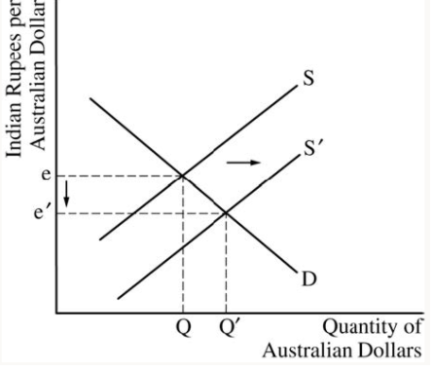
C One point is earned for drawing a correctly labeled graph of the foreign exchange market of the Australian dollar.
One point is earned for showing a rightward shift in the supply curve for Australian dollars and a depreciation in the Australian dollar.
D One point is earned for stating that Australian exports will increase.
E · One point is earned for stating that Australian unemployment decreases.
2.
a. 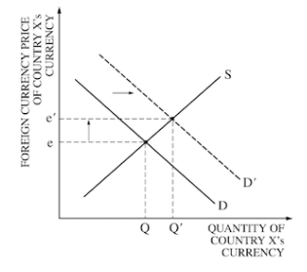
b 1 point: Country X’s imports will increase
1 point: Country X’s exports will decrease
1 point: explanation of why imports or exports change that refers to relative price differences. Note: one explanation is sufficient for full credit.

Include correctly labeled diagrams, if useful or required, in explaining your answers. A correctly labeled diagram must have all axes and curves clearly labeled and must show directional changes.
The exchange rate between the Australian dollar and the Indian rupee is determined in a flexible foreign exchange market.
a. Assume India is currently in recession. What fiscal policy action could the Indian government take to eliminate the recession?
b. What would be the effect of the fiscal policy action identified in part (a) on interest rates in India?
c. Draw a correctly labeled graph of the foreign exchange market for the Australian dollar. Show on your graph the impact of the change in interest rates identified in part (b) on each of the following.
i. The supply of Australian dollars
ii. The equilibrium exchange rate of the Australian dollar
d. What would be the effect of the change in the exchange rate identified in part (c)(ii) on Australian exports?
e. What would be the effect of the change in Australian exports identified in part (d) on Australian unemployment?

Country X has a flexible exchange rate and international capital mobility. Political turmoil outside of Country X generates capital flow into Country X.
- Using a correctly labeled foreign-exchange market graph, explain the impact of the capital inflow on the international value of the currency of Country X.
- For Country X, explain the effect of the change in the international value of its currency on each of the following.
- Exports
- Imports

